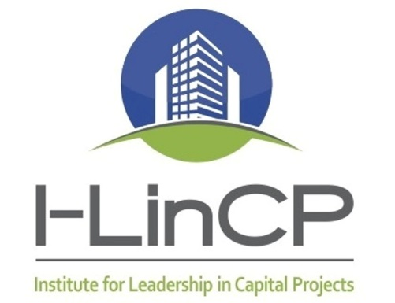

“CIRCLES OF EXCELLENCE” PROPOSAL WORKSHEET
A "Circle" is made up of an area of focus used to EXPLORE an idea or issue, produce a desired OUTCOME, and/or create a DELIVERABLE (product or service).
https://i-lincp.wildapricot.org/Circles
Return completed form to Carla Bingaman: Carla.bingaman@i-lincp.org

YOUR NAME:
EMAIL:
OFFICE PHONE:
MOBILE:

1) Proposed name of Circle (Brief headline description):

2) What are the needs for or benefits of this Initiative and why should I-LinCP pursue this?

3A) What (generally) is to be accomplished?

3B) Any specific deliverables?
4) Up to now, who has participated in this discussion? STAR * the lead person.

5) Plot your best estimate of the value this initiative will deliver to our industry stakeholders and resources (time, money, effort, technology, etc.) it will require.  Hi  Low  Low Hi | 6) What other resources (people or funds) would be helpful in moving this forward?

- SEE NEXT PAGE -
CIRCLE DETAILS
(To be defined at first team meeting after approval of Circle)

Team Members: (Star * the lead)
NAME | COMPANY | EMAIL | TELEPHONE
Statement of Need:
Example:
Integrated Project Delivery (IPD) is another tool in the evolution of methodologies available to Capital Project Owners for project delivery. The need to find new ways to reduce costs, cost overruns, disputes, errors and omissions, and schedule duration is ever-present. Certain project types, in particular, need new ways of fostering collaboration, data sharing, and involvement of all parties at the earliest point possible. IPD is becoming more commonplace, therefore, a greater familiarity and understanding is required. Public Capital Project Owners need to be able to use as many of the techniques of IPD, along with its mindset, as possible within the limitations of existing law.
Mission:
Example:
Provide information to Public Capital Project Owners and design/construction stakeholders about the theoretical and practical implications and processes of developing and executing an IPD or IPD-ish (without a formal three-party contract) process.
Goals and Deliverables:
Example:
1. Produce a “white paper” that describes the essential characteristics of IPD, its benefits and drawbacks, best practices, along with some recommendations. Include information on how public Capital Project Owners can use as many IPD techniques as possible within the law.
2. Stage a one-day or one-and-a-half-day IPD mockup and workshop. The mockup should use teams with a mixture of architects, engineers, consultants, owners, and contractors. Each team will present their findings and conclusions.

